Western Region
Investigating Beyond Swiss Cheese and Dominoes: CAST Accident Analysis Overview

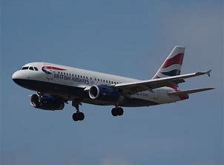

by
Simon Whiteley
Whitely Safety

7:00pm, Tuesday, 24th September 2019
BAWA Leisure Centre, 589 Southmead Road,
Filton, Bristol BS34 7RG

SaRS members and guests welcome. Attendance is free.
Booking is via Eventbrite
For further information please email: SARSW@SaRS.org.uk
SaRS Website: http://www.sars.org.uk

